Appendix 2:

Industrial Land Planning, Control Indicators, Map of Functional Zones in Huangpu district/Development District

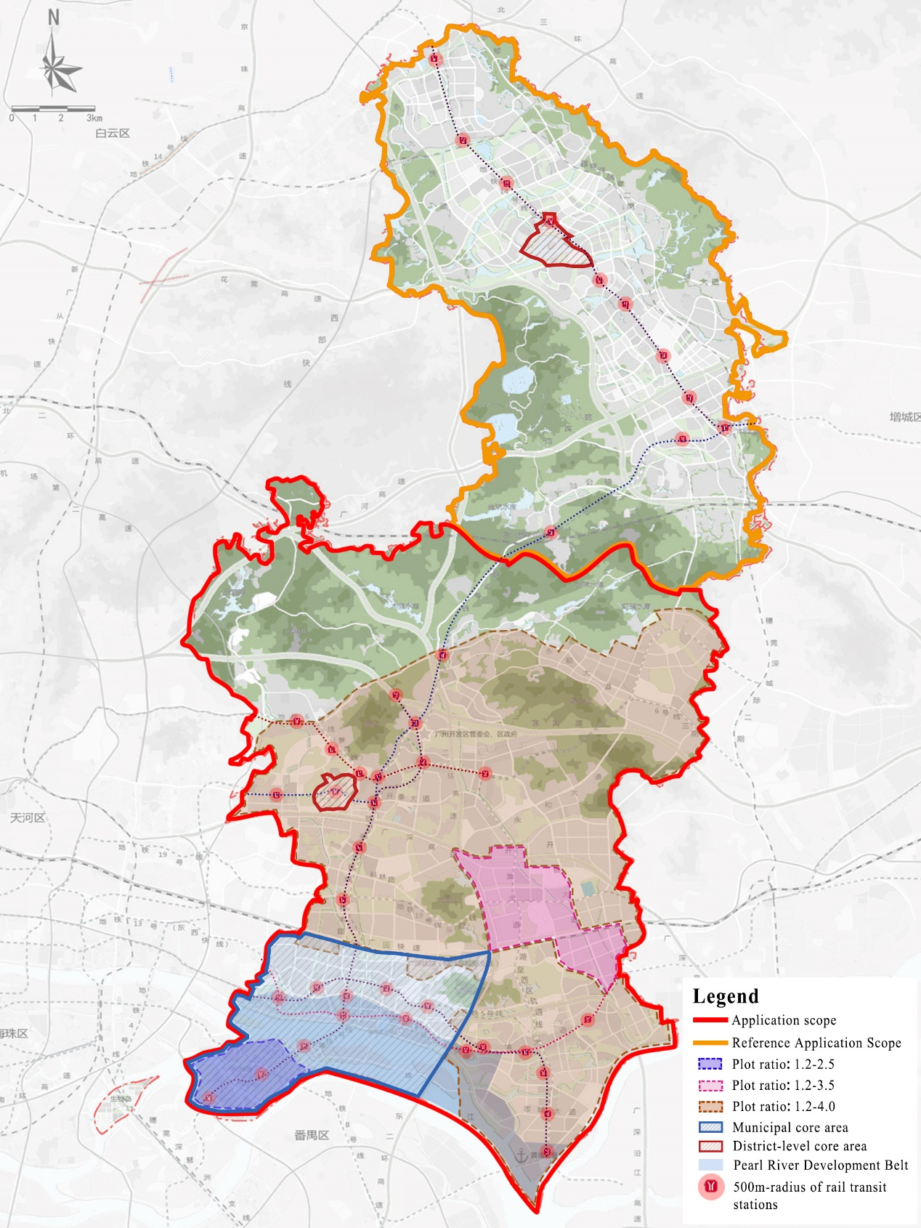

Notes:

1. For industrial land within 200 meters from the Pearl River, its development intensity shall comply with management and control requirements of Guangzhou’s “one river, two banks and three belts” development plan.

2. For industrial land involving cultural relics, height limit for aerial vehicles, and other requirements, relevant regulations shall be observed.

3. The legend shows rail transit stations either built, under construction, or with the planning and siting formalities completed. Where there are special requirements for areas within their 500m radius or in their land and space plan, such requirements shall be met. The location of the rail transit stations is subject to change according to the actual construction or plan.